What is LangChain?

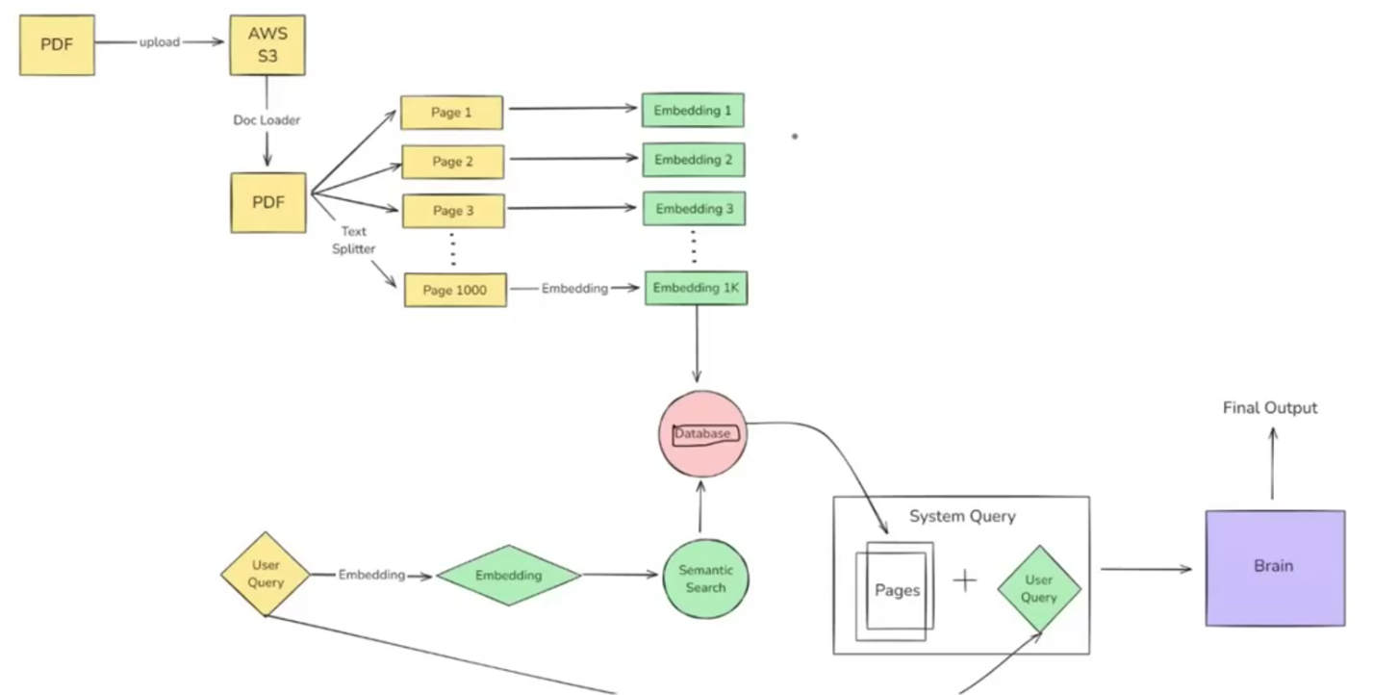LangChain is an open-source framework for developing applications powered by LLMs.

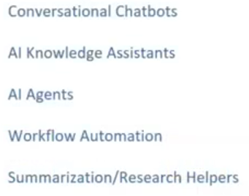Benefits Use cases

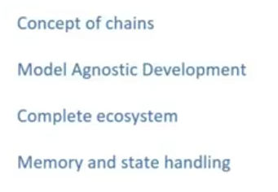

Components of LangChain

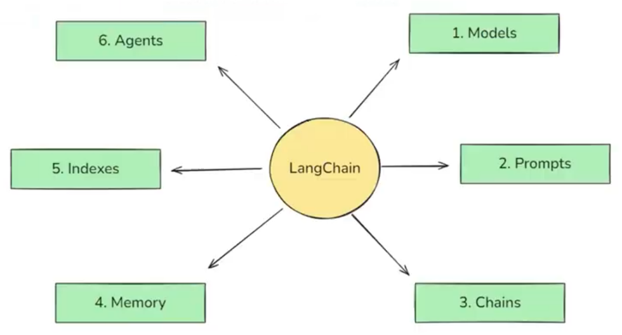

1. Model  
   In LangChain, **models** are the core interfaces through which we can interact with AI models.

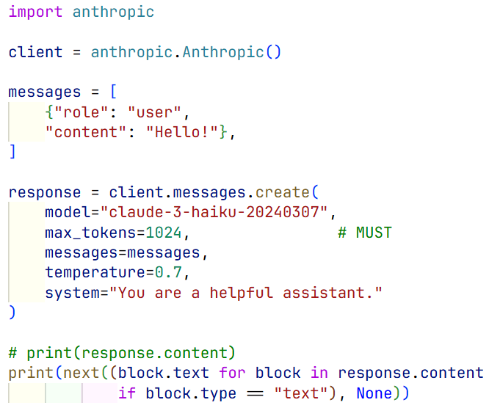Quick starter codes:

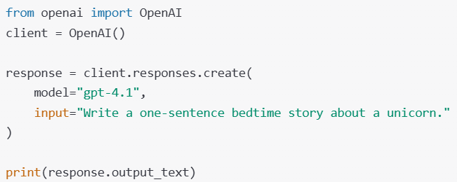

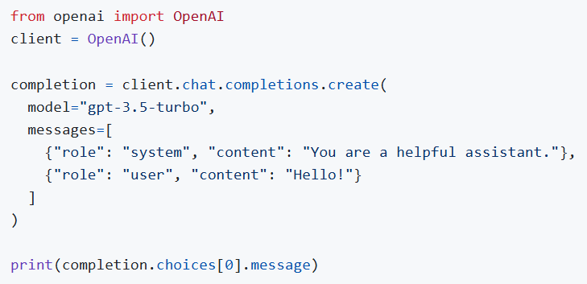

After LangChain:

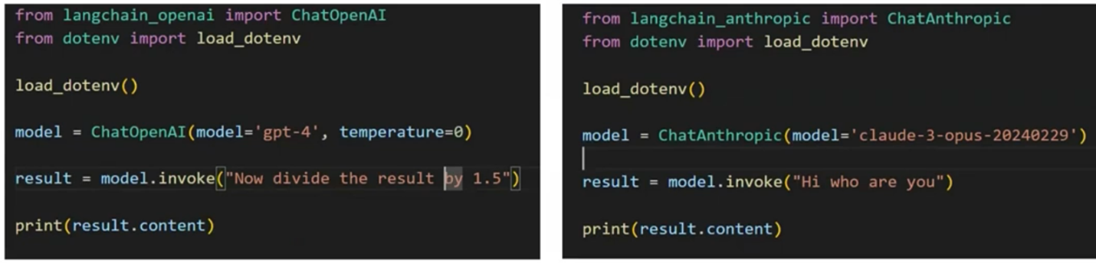

1. Language Models: (Hugging Face is open-source model provider)
   1. LLMs (from langchain_openai import OpenAI) a str -> a str
   2. Chat Models (from langchain_* import Chat* ) sequence of messages -> messages
2. Embedding Models: (from langchin_* import *Embeddings ) text -> numbers as vector embeddings
3. Prompts
4. Dynamic and Reusable Prompts
5. Role-Based Prompts
6. Few-Shot Prompts
7. Chains

Chains are complex pipelines, simply by using **|** notation. Like -

1. Parallel Chain (like In-Depth Research Paper Generation)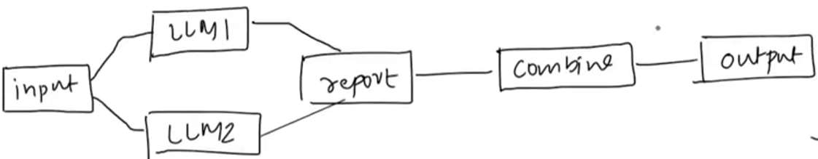
2. Conditional Chain (like AI Agent feedback)

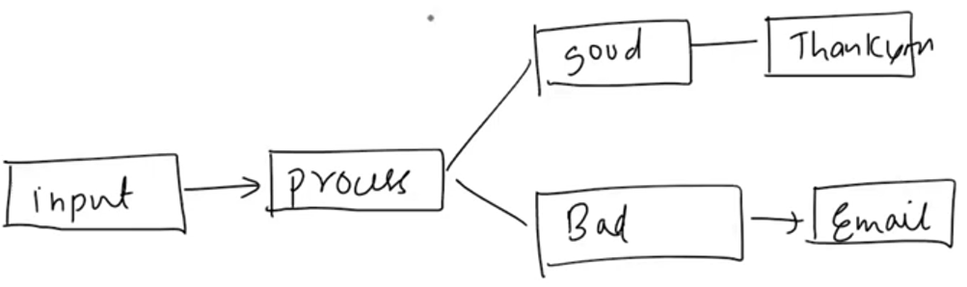

1. Index

Indexes connects our application to external knowledge sources (like PDF, db, website)

1. Doc Loader
2. Text Splitter
3. Vector Store (db for embeddings)
4. Retrievers
5. Memory

Pure LLM calls are stateless (each request is independent)

1. ConversationBufferMemory: Stores a transcript of recent messages. Great for short chats but can grow large quickly.
2. ConversationBufferWindowMemory: Only keeps the last N interactions to avoid excessive token usage. Older important information can be missed.
3. SummarizerBasedMemory: Periodically summarizes older chat segments to keep a condensed memory footprint.
4. CustomMemory: For advanced use cases, in a custom memory class we can store specialized state. Like – I am a software engineer, give concise python code snippets.
5. AI Agents

ChatBots / LLMs can only think and talk. Agents can do the work.

LLMs only have brain and mouth but Agents also have hands.

Agents have - Reasoning Capability and Tools (like hit api get data)

Example – Multiply today’s Kolkata’s temperature with 3

Process –

[ Available Tools – Calculator , WeatherAPI ]

User asks AI Agent -> reasoning by like - Chain of Thoughts -> hits WeatherAPI -> gets data

-> checks for tools like Calculator -> calls calculator with params -> returns final output

**1. MODEL:**

The Model Component in LangChain is a crucial part of the framework, designed to facilitate interactions with various language models and abstracts the complexity of working directly with different LLMs, chat models, and embedding models, providing a uniform interface to communicate with them. This makes it easier to build applications that rely on Al-generated text, text embeddings for similarity search, and retrieval-augmented generation (RAG).

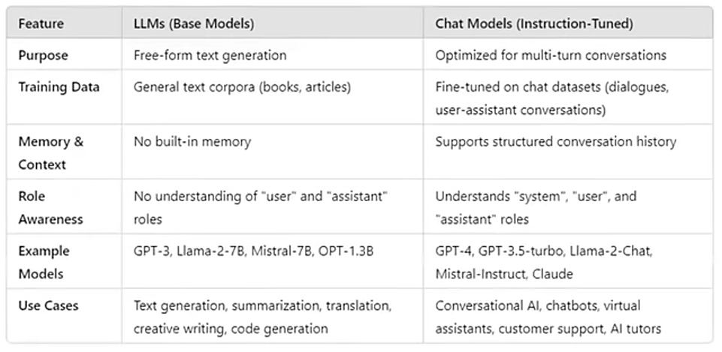

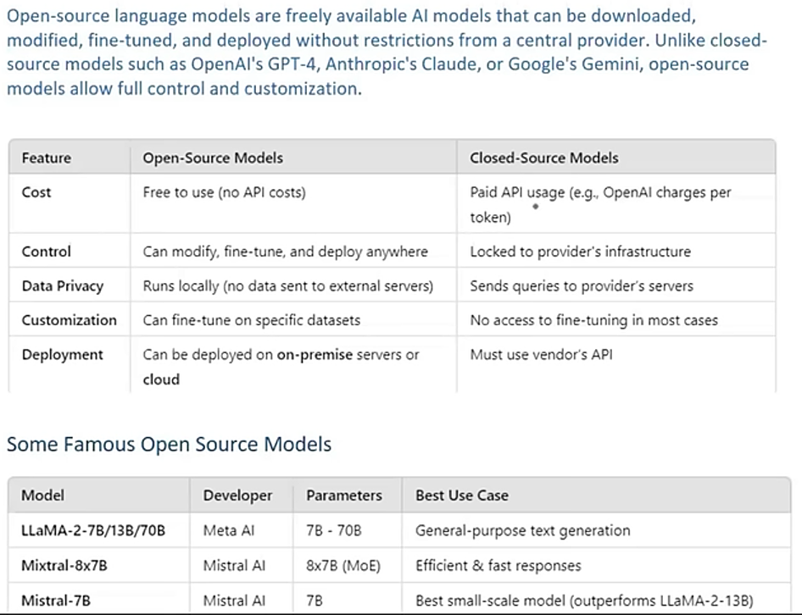

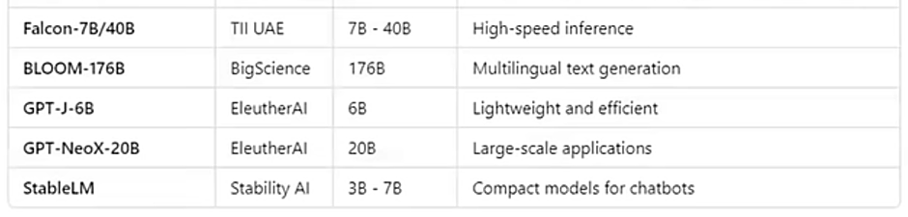

Open Source Models – like from 🤗 Hugging Face , 🦙 Ollama Store

Ways to use OS Models –

1. Using HF Inference API (Free tier available)
2. Running Locally

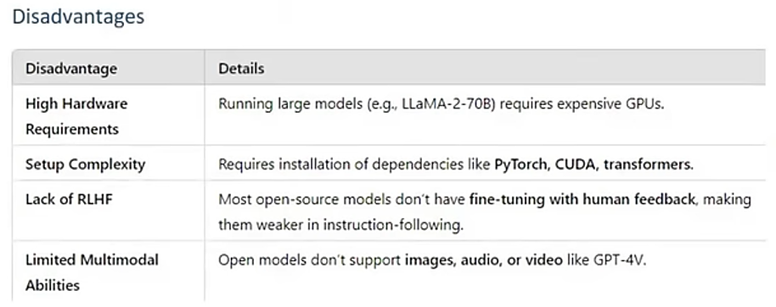

**2. PROMPT: (Structured Input)**

Example of dynamic prompt

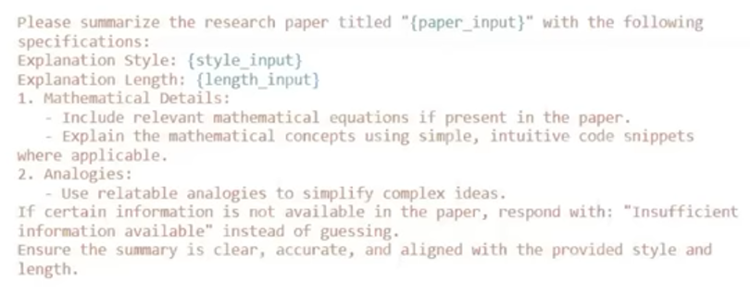

Prompt Template

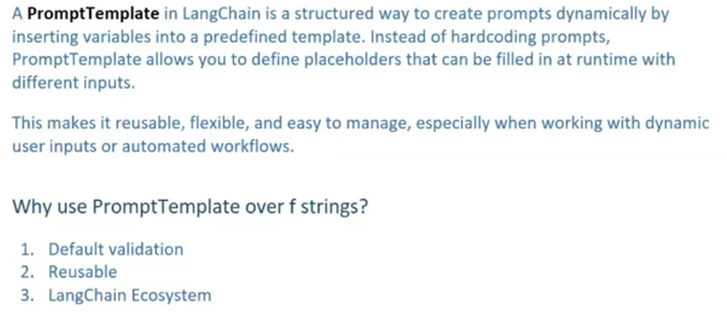

Single-turn dynamic prompting using PromptTemplate (also have params like partial_variables as dict)

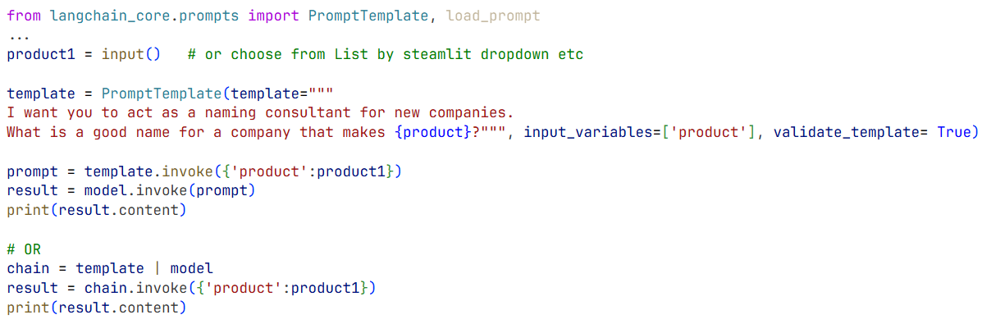

With above problems are –

* 1. Multi-turn Conversation & who told what - ChatPromptTemplate
  2. Can’t recall previous convo – fix is MessagesPlaceholder

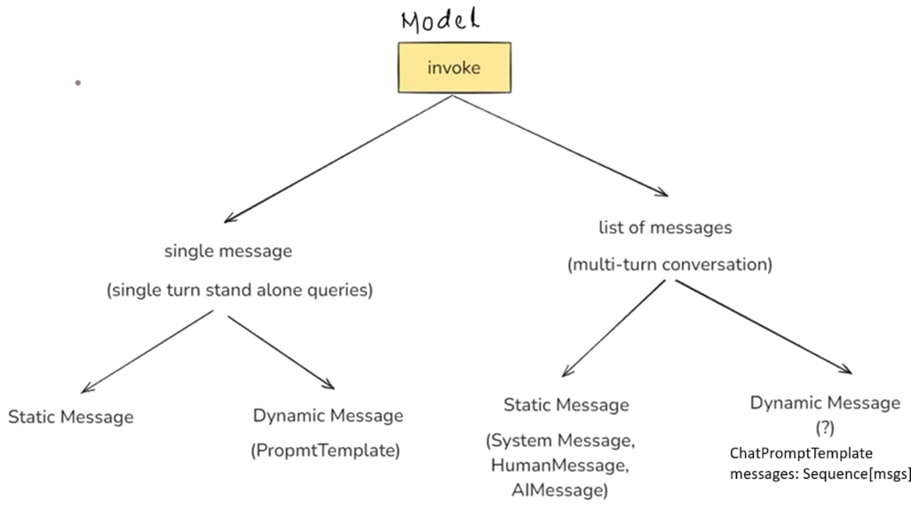

from langchain_core.prompts import PromptTemplate, load_prompt, ChatPromptTemplate, MessagesPlaceholder

from langchain_core.messages import SystemMessage, HumanMessage, AIMessage

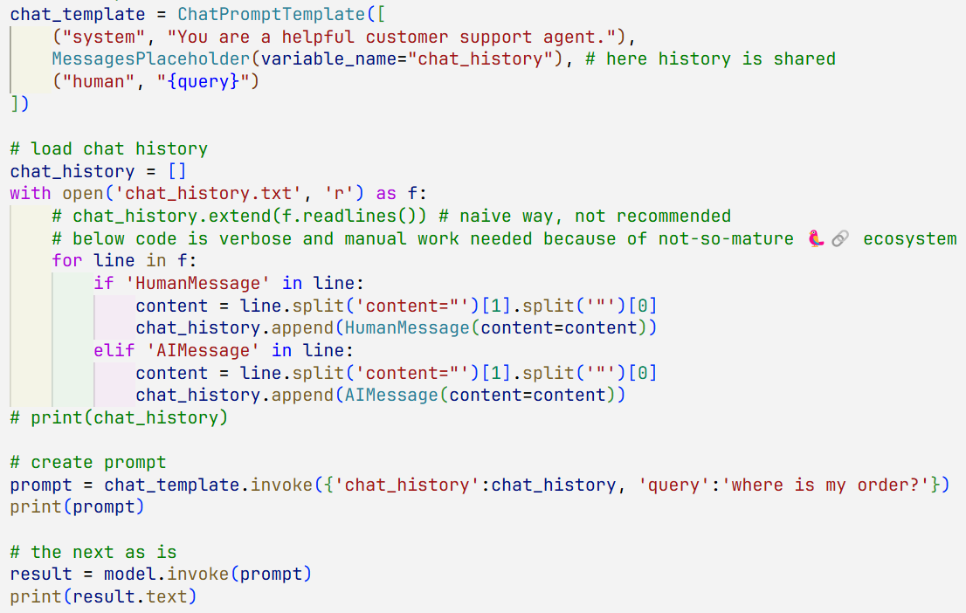

* **Structured Output**

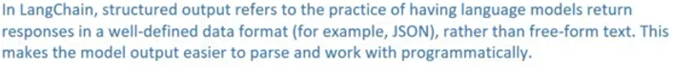

Why do we need –

1. Data extraction (from resume fetch must-have infos to dump to database)
2. Build API (Amazon text review to – topics covered, pros, cons, sentiment)
3. Build Agents (Agents don’t work on textual data, they need specific format as input)

Ways to get structured output – LLMs which

1. can generate natively (with_structured_output(schema=, method=) )

Schema=

* 1. TypedDict (simple and
  2. Pydantic
  3. json_schema

Method=

* 1. json_schema
  2. json_mode – Claude, Gemini
  3. function_calling - OpenAI

1. can’t generate natively (with output parser)- like TinyLlama

**TypedDict:**

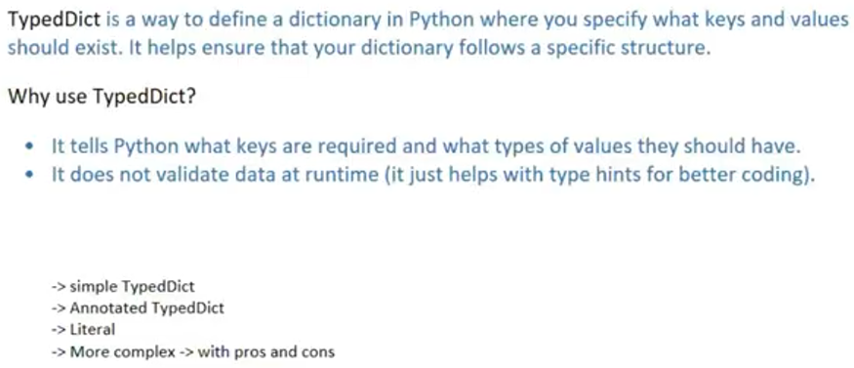

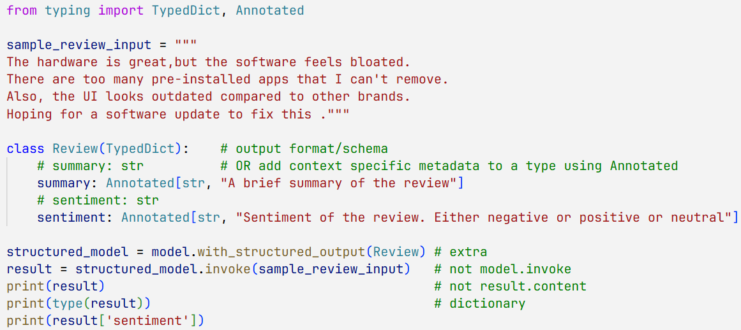

**Pydantic:**

Pydantic is a third-party library that builds on Python's type hints to provide powerful **data validation, parsing, and serialization** at runtime. It uses Python type annotations to define data schemas, but unlike TypedDict, it **actively enforces these types and rules when you create an instance** of a Pydantic model.

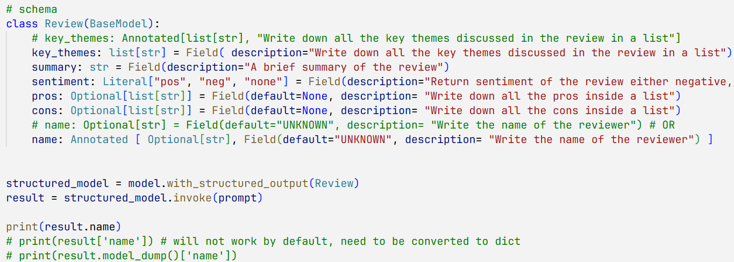

**Json-Schema:**

Platform independence needed. like backend with Python, frontend with React etc.

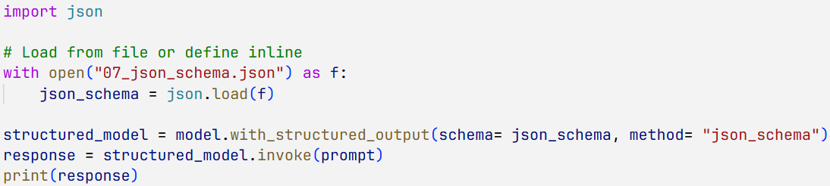

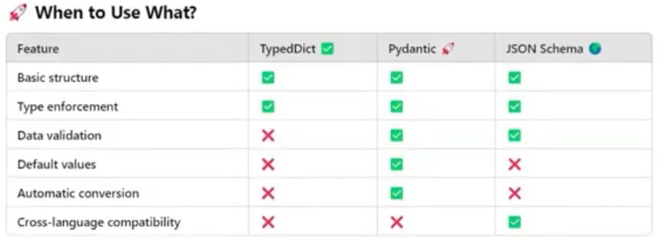

**Output Parsers:**



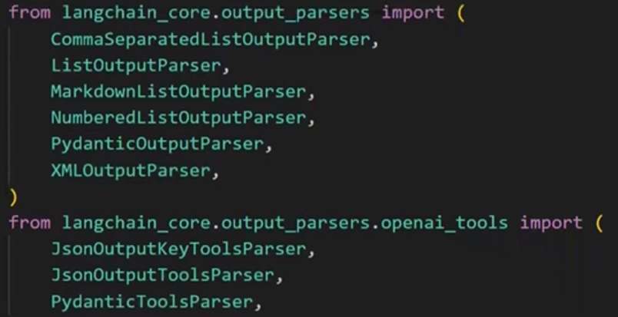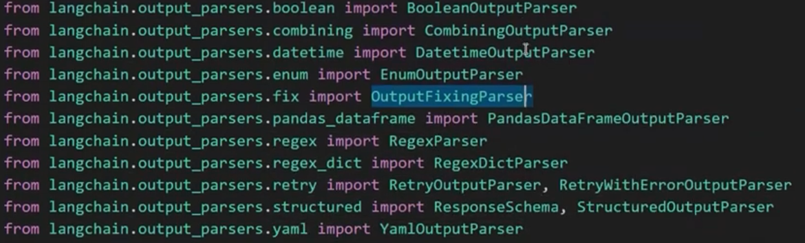

Paser.parse() or parser.invoke()

**StrOutputParser:**

Parses only string content from response of ChatModel. No need to extract via result.content

It’s actually helpful if output of a model needs to be used as input of another model.

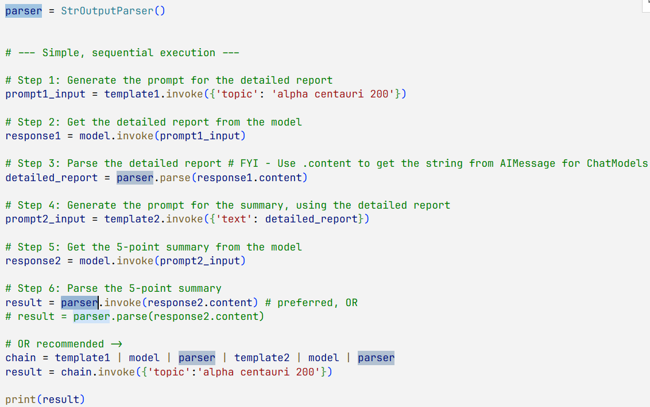

**JsonOutputParser:** Output will be dictionary like

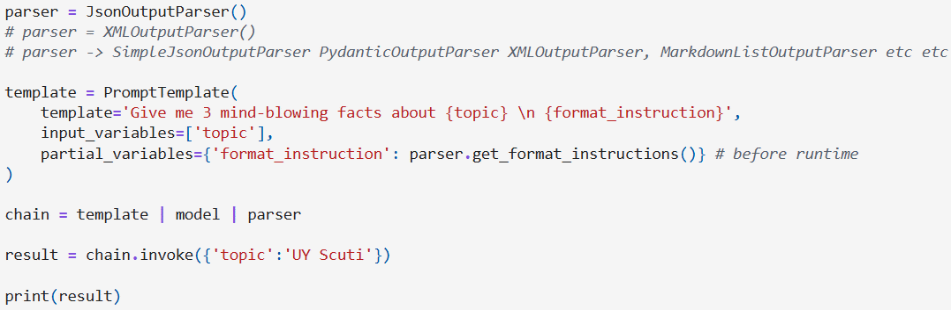

**StructuredOutputParser:**

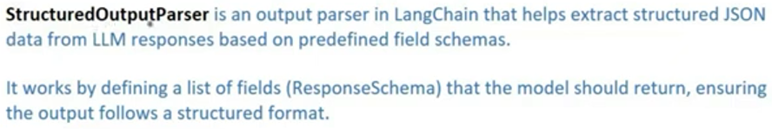

Disadvantage:

No data validation. In the schema we can define datatype

schema = [ResponseSchema(name=…, description=… type="string"), … ]

parser = StructuredOutputParser.from_response_schemas(schema)

...

but does not guarantee to be returned in that exact format.

**PydanticOutputParser:**

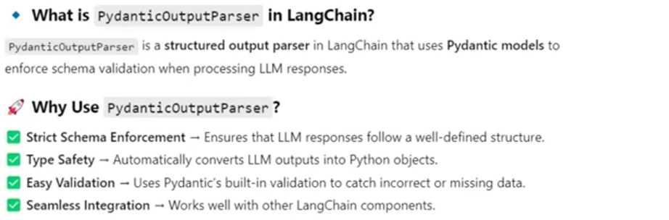

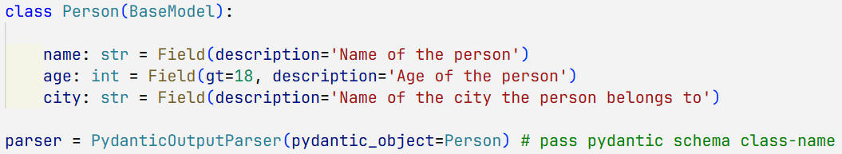

…

For more flexibility we can use **RunnablePassthrough** (check notebook)

**3. Chains:**

View complete chain by - chain.get_graph().print_ascii()

1. Simple Chain:

chain = prompt | model | parser

result = chain.invoke({'topic':'cricket'}) # previously it was .run()

print(result)

1. Sequential

chain = prompt1 | model | parser | prompt2 | model | parser

result = chain.invoke({'topic': 'Unemployment in India'})

1. Parallel

from langchain.schema.runnable import RunnableParallel

parallel_chain = RunnableParallel({

    'notes': prompt1 | model1 | parser,

# these keys => labels/keys for respective output when invoked

    'quiz': prompt2 | model2 | parser

})

merge_chain = prompt3 | model1 | parser

chain = parallel_chain | merge_chain

1. Conditional

from langchain.schema.runnable import RunnableParallel, RunnableBranch, RunnableLambda

sentiment_chain = template_initial_ip | model_openai | parser_for_sentiment

(here output is either positive or negative)

# below is like

# if condition1: chain1

# elif condition2: chain2

# else default_runnable

branch_chain = RunnableBranch(

    (lambda x:x.sentiment == 'positive', template_pos_ip | model_huggingface | str_parser),

    (lambda x:x.sentiment == 'negative', template_neg_ip | model_anthropic   | str_parser),

    RunnableLambda(lambda x: "could not find sentiment")            )

chain = sentiment_chain | branch_chain

* **Runnables:** (like Lego blocks)

Unit of work - Input, process, output

Common interface – invoke, batch, stream

Connect sequentially, so that one’s output, is automatically other’s input.

Multiple joined runnable can also act as single runnable.

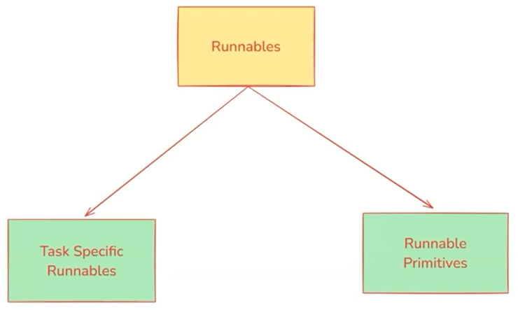

**Task Specific Runnable:** These are core LangChain components that have been converted into Runnable so they can be used in pipelines.

Purpose: Perform task-specific operations like LLM calls, prompting, retrieval. etc.

Examples:

ChatOpenAI - Runs an LLM model.

PromptTemplate - Formats prompts dynamically.

Retriever - Retrieves relevant documents.

**Runnable Primitives:** These are fundamental building blocks for structuring execution logic in Al workflows.

Purpose: They help orchestrate execution by defining how different Runnables interact (sequentially, in-parallel, conditionally, etc.)

Examples:

RunnableSequence - Runs steps **in order** (I operator).

RunnableParallel - Runs multiple steps **simultaneously**.

RunnableMap - Maps the same input across multiple functions.

RunnableBranch - Implements **conditional execution** (if-else logic).

RunnableLambda - Wraps **custom Python function** into Runnable.

RunnablePassthrough - Just forwards input as output (acts as a placeholder).

* **Memory** : In LangGraph Section
* **RAG (Retrieval Augmented Generation):**

RAG is a technique that combines information retrieval with language generation,

where a model retrieves relevant documents from a knowledge base and then uses

them as context to generate accurate and grounded responses.

Benefits of using RAG

1. Use of up-to-date information

2. Better privacy

3. No limit of document size

Components of RAG:

1. Document Loader (from BaseLoader -> like TextLoader, PyPDFLoader, WebBaseLoader, CSVLoader)

2. Text Splitter

3. Vector Database

4. Retriever

* **Document loader**

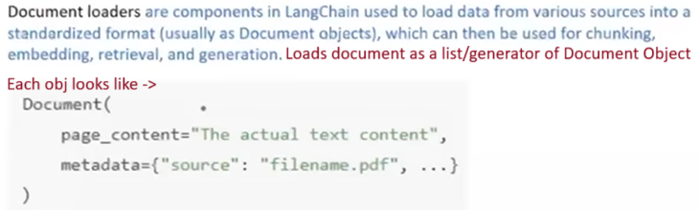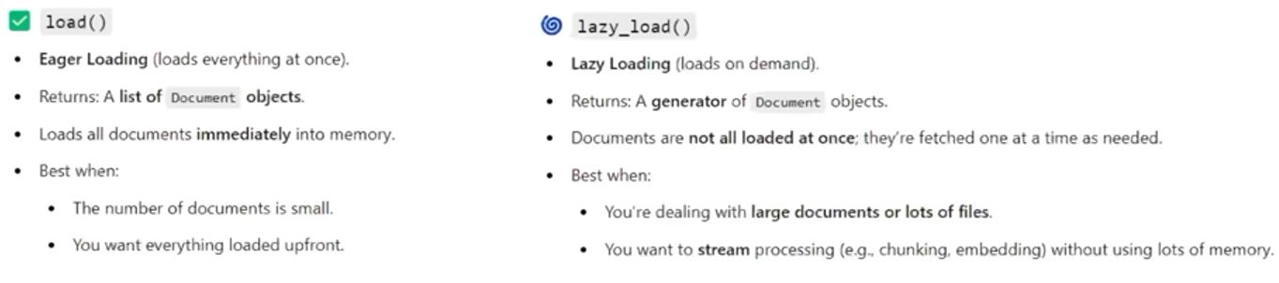

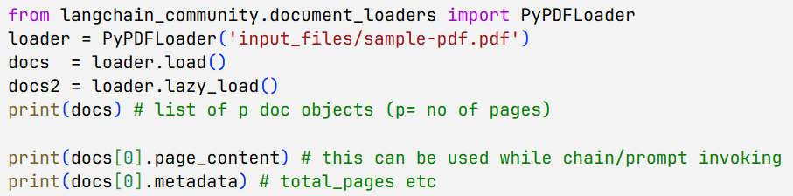



**DirectoryLoader:**

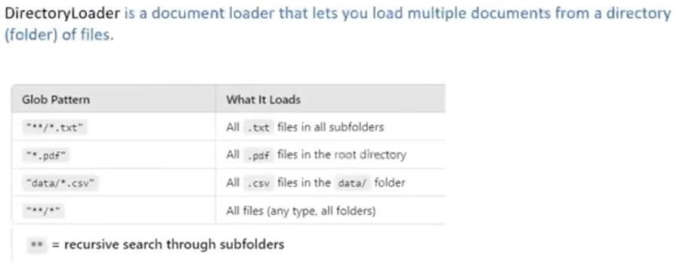

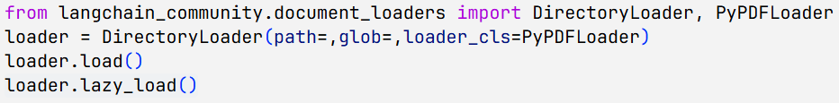

# Inside folder every pdf’s page will be loaded one after another.

Metadata -> total_page: all combined page no , page: current pdf page no

* **Text Splitting:**

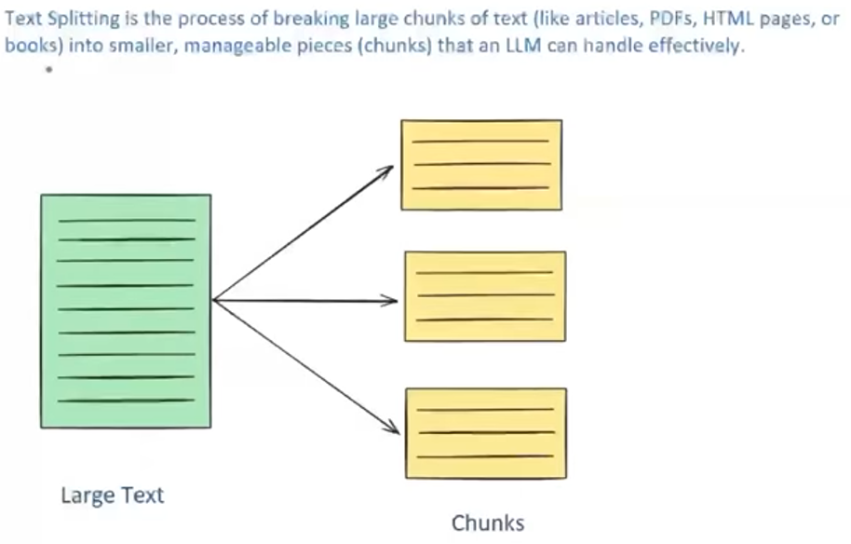

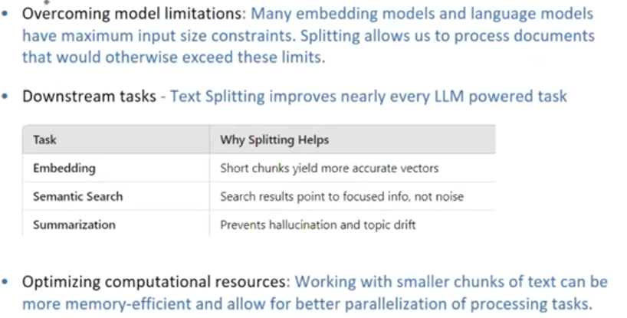

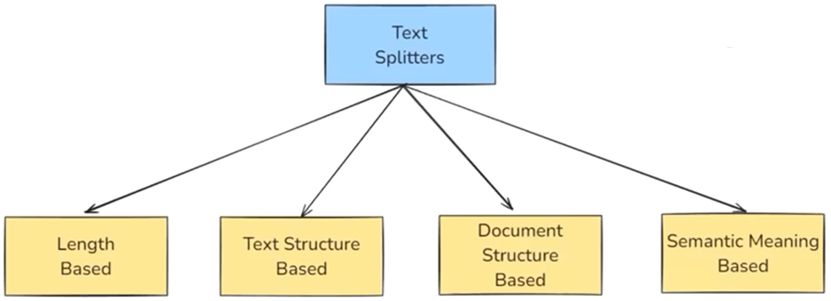

**1. Length Based – CharacterTextSplitter:**

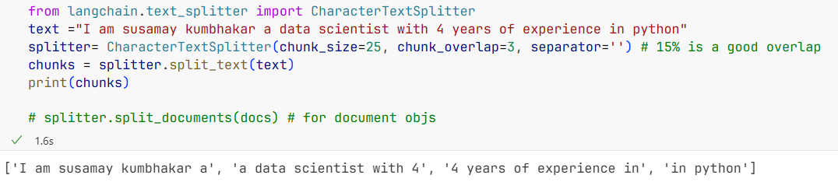

**2. text structure based - RecursiveCharacterTextSplitter:**

Tries hierarchical splitting ->like paragraph - \n\n, line - \n, word - ' ', character - ''

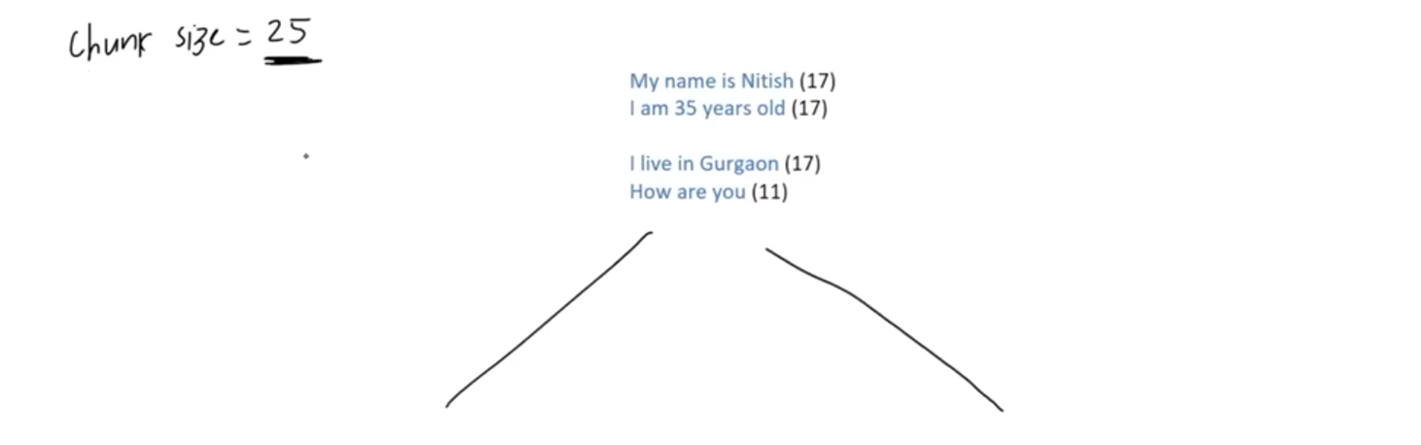

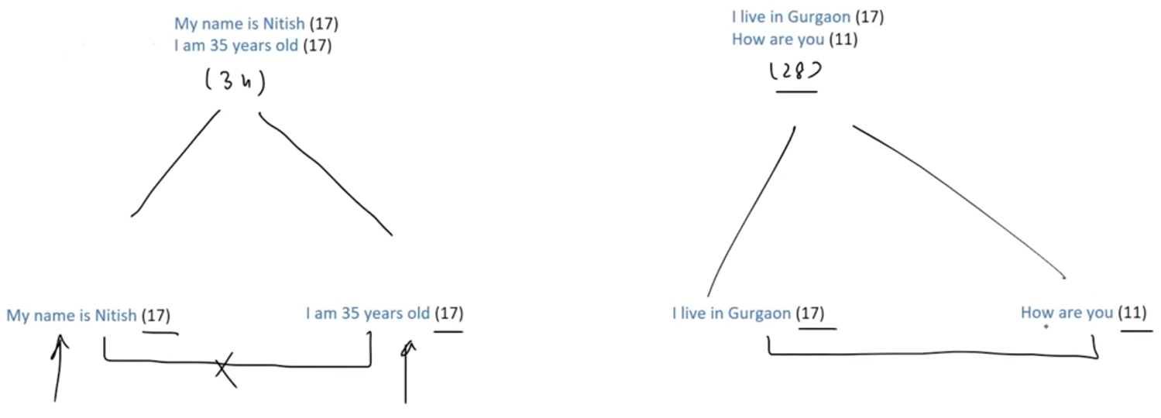



**3. document structure based - Recursive Character Text Splitter:**

(Diff format - like markdown or python file) - special case of previous

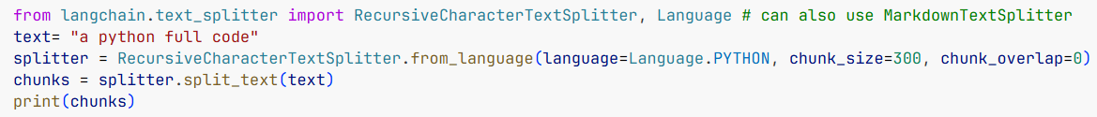

**4. Semantic Text Splitter:**

Let’s say given 5 sentences: S1, S2, S3, S4, S5

1. Generate embeddings for consecutive pairs: (S1-S2), (S2-S3), (S3-S4), (S4-S5)
2. Compute cosine similarities for each pair → get 4 similarity scores
3. Calculate mean and standard deviation (SD) of these scores
4. If a similarity drops significantly (e.g., below mean − SD), insert a split between those sentences

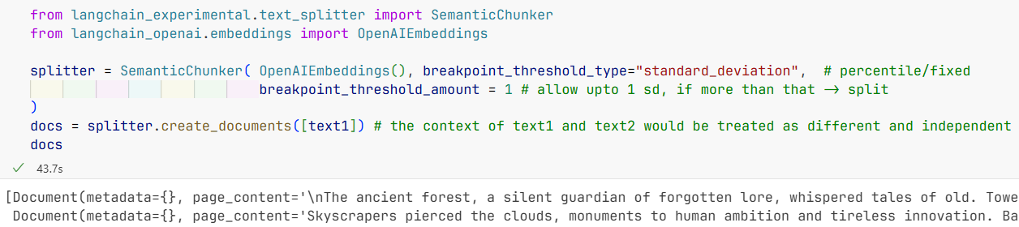

**Every splitter obj has these methods ->**

**split_text(text):** Splits a single string into text chunks.

**split_documents(docs):** Splits a list of LangChain Document objects (preserving metadata) into smaller Document chunks.

**create_documents([sample]):** Converts a list of raw strings (with optional metadatas) into Document objects and then splits them into chunks.

* 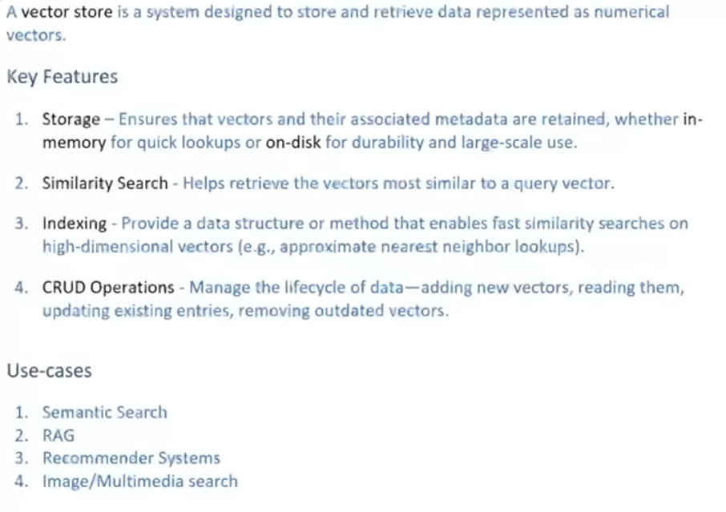**Vector Store -**

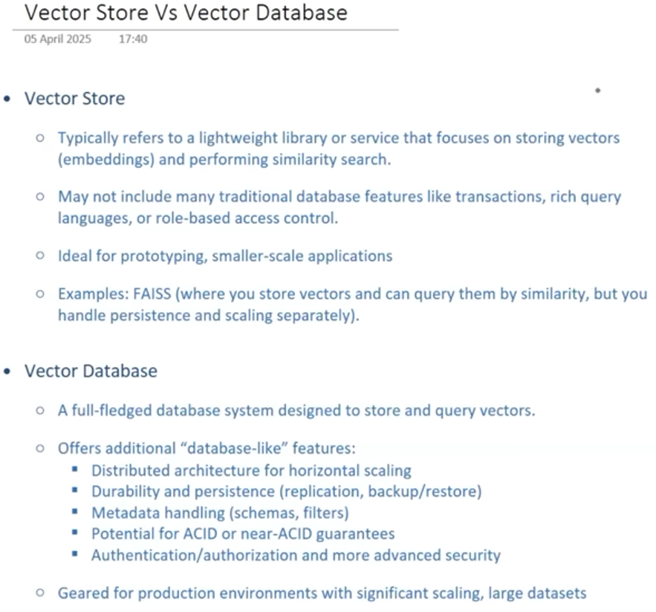

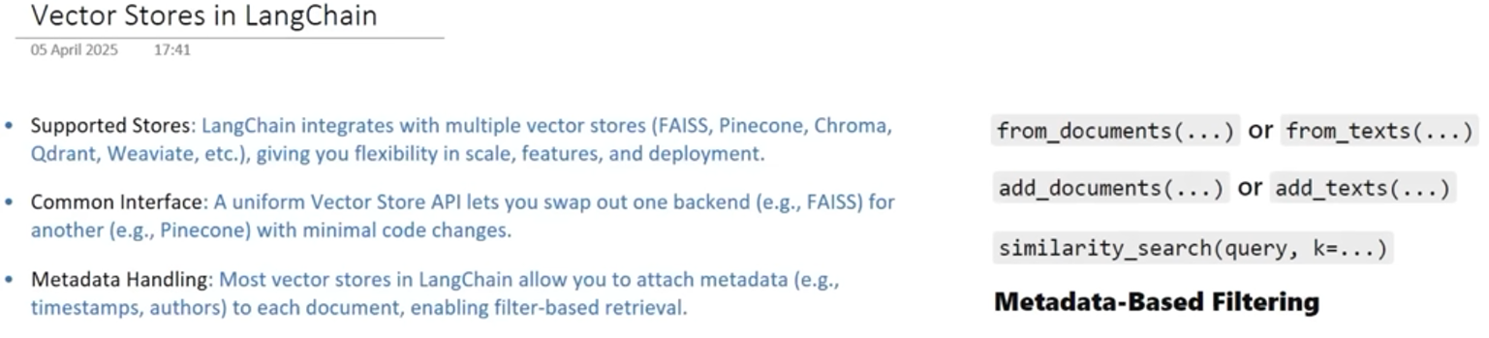

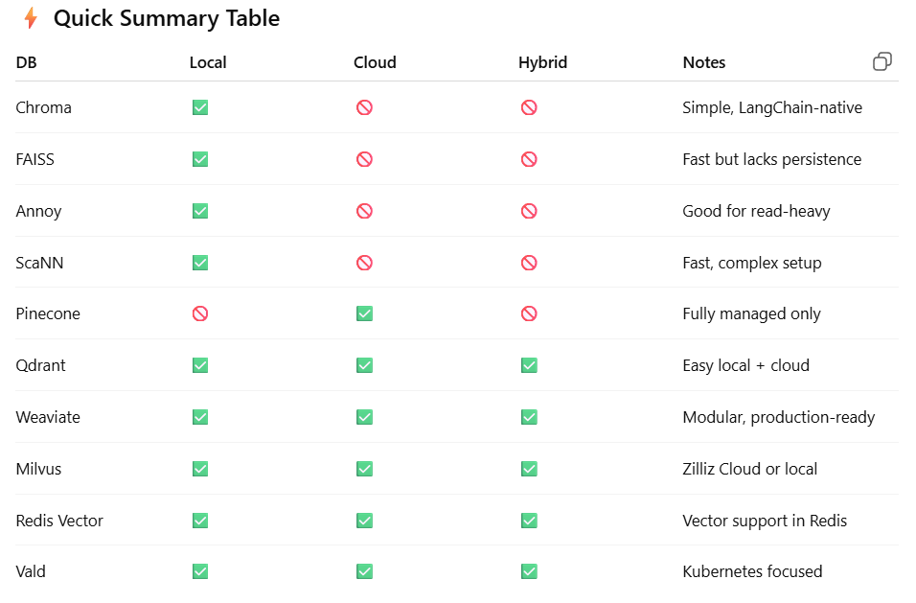

**ChromaDB –**

from langchain.vectorstores import Chroma -> depricated

from langchain_chroma import Chroma

vector_store = Chroma(

    embedding_function=OpenAIEmbeddings(),

# here shape for each vector is (1,1536), so each plotted in 1536 dim

    persist_directory='my_chroma_db',

    collection_name='sample' )

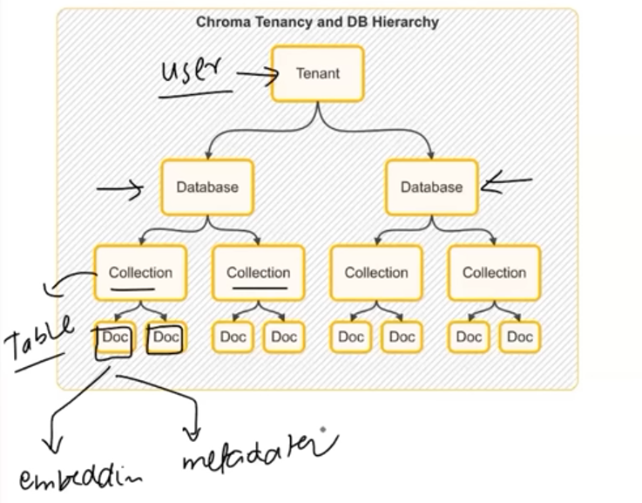

vector_store.add_documents(docs)

vector_store.similarity_search(query='Who among these are a bowler?', k=2)

vector_store.similarity_search_with_score(.,,. , filter={"team": "CSK"})

vector_store.update_document(document_id=…, document=updated_doc1)

vector_store.delete(ids=[…])

vector_store.get(include=['embeddings','documents', 'metadatas'])

* **Retriever:**

A retriever is a component in LangChain that fetches relevant documents from a data source in response to a user's query. There are multiple types of retrievers. All retrievers in LangChain are runnable.

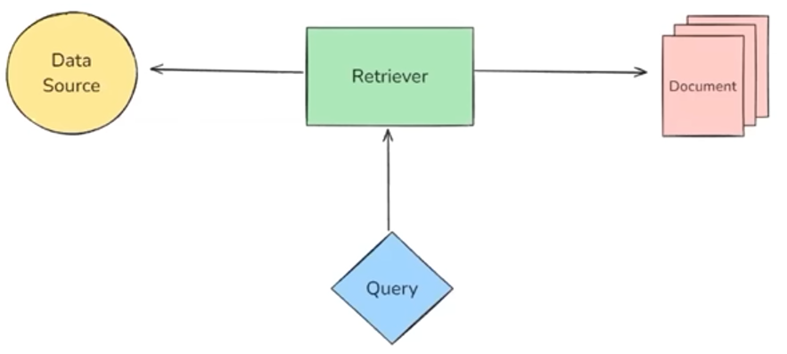

Categories -

1. Data Source (like Wikipedia retriever, archive retriever, vector store)

2. Search Strategy (MMR - Maximum Marginal Relevance, MultiQuery, Contextual Compression etc)

**Wikipedia Retriever (langchain_community.retrievers import WikipediaRetriever)**

A Wikipedia Retriever is a retriever that queries the Wikipedia API to fetch **relevant** content for a given query.

How It Works

1. You give it a query (e.g., "Albert Einstein")

2. It sends the query to Wikipedia's API

3. It retrieves the most relevant articles, i.e. some logic is written, so it’s not a DocumentLoader

4. It returns them as LangChain Document objects. [Document(metadata=, page_content=), … ]

Code:

**Vector Store Retriever**

A Vector Store Retriever in LangChain is the most common type of retriever that lets you

search and fetch documents from a vector store based on semantic similarity using vector

embeddings.

How It Works - retriever = vectorstore.as_retriever(search_kwargs={"k": 2})

1. You store your documents in a vector store (like FAISS, Chroma, Weaviate, Qdrant)

2. Each document is converted into a dense vector using an embedding model

3. When the user enters a query.

It's also turned into a vector

The retriever compares the query vector with the stored vectors

It retrieves the top-k most similar ones

Other Retrieving Methods:

Query (similarity search) # default case

MMR (Maximal Marginal Relevance) Retriever



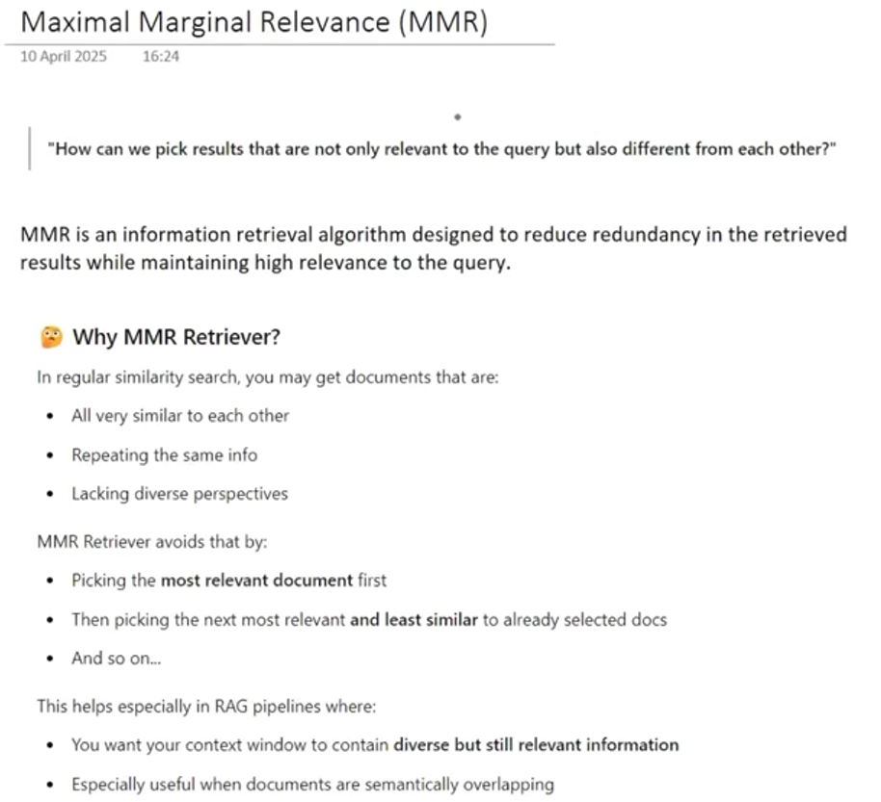

Multi-Query Retriever

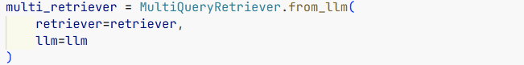

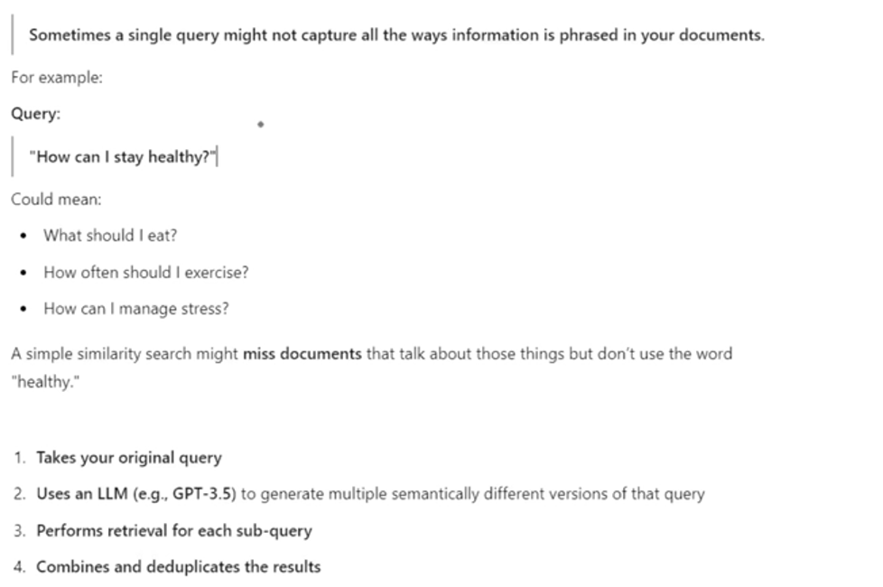

Merger Retriever



Contextual Compression Retriever

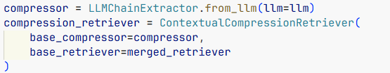

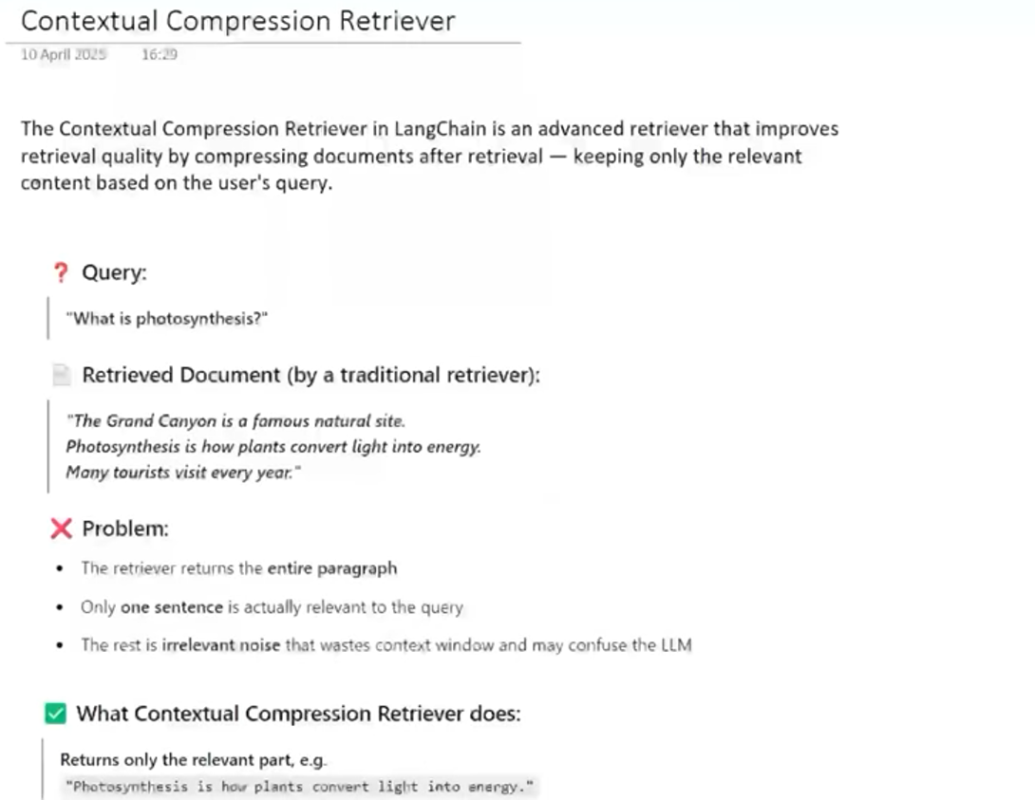

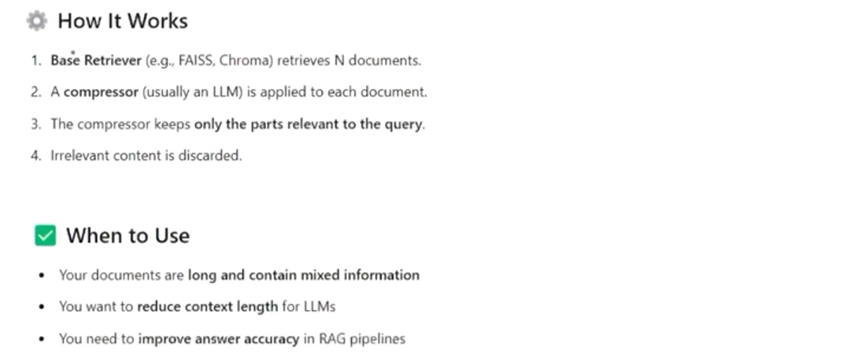

# Invoke By –

query = "What is Chroma used for?"

results = retriever.invoke(query)

for doc in results:

    print(doc.page_content)

**Fine-Tuning:**

1. Supervised FT – (labelled dataset is provided) like prompt -> desired output. 1k~100k pairs provided.

2. Continued Pretraining – (unsupervised) like subtitle file fed to LLM (like pretraining but smaller)

3. RLHF – Reinforcement Learning on Human Feedback

**Process: (supervised)**

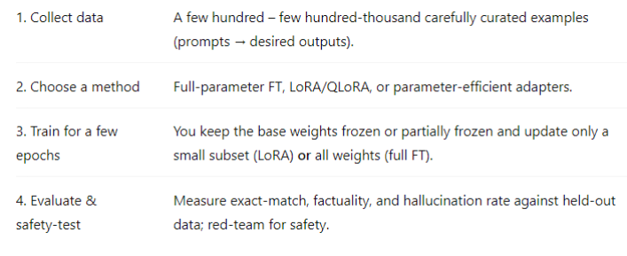

It’s computationally very expensive to FT a model, that’s why RAG is used.

* **RAG:**

✅ What Problems Does RAG Solve?

- 🔍 **Lack of knowledge beyond training** → Injects external data at runtime.

- 🧠 **Hallucinations and unreliable responses** → Grounds answers in retrieved documents.

- 💾 **Token/context limits** → Selectively retrieves only relevant chunks.

- 💸 **Expensive LLM fine-tuning** → Avoids retraining by using dynamic context injection.

- 📄 **Domain-specific/private data** → Enables LLMs to answer from your own content (PDFs, databases, wikis).

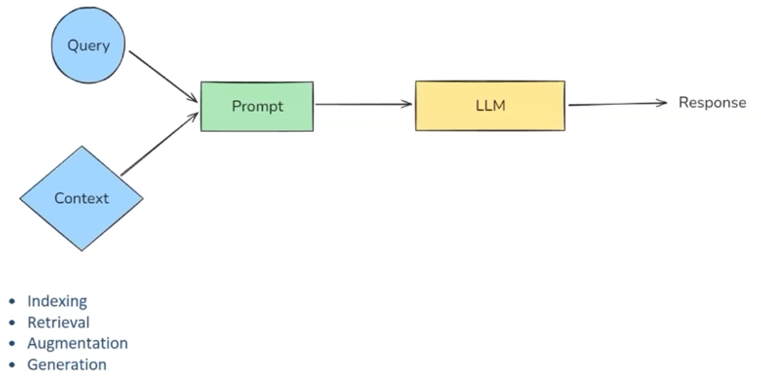

**Indexing** - Indexing is the process of preparing our knowledge base so that it can be efficiently searched at query time. This step consists of 4 sub-steps.

1. Document Ingestion - You load your source knowledge into memory.

Examples:

• PDF reports, Word documents

• YouTube transcripts, blog pages

• GitHub repos. internal wikis

SQL records, scraped webpages

Tools: LangChain loaders ( PyPDFLoader , YoutubeLoader , GitLoader etc.)

2. Text Chunking - Break large documents into small, semantically meaningful chunks

Why chunk?

• LLMs have context limits (e.g., 4K—32K tokens)

• Smaller chunks are more focused — better semantic search

Tools: RecursiveCharacterTextSplitter , SemanticChunker

3. Embedding Generation - Convert each chunk into a dense vector (embedding) that captures its

meaning.

Q. Why embeddings?

A. Similar ideas land close together in vector space; Allows fast. fuzzy semantic search

Tools: OpenAIEmbeddings, SentenceTransformerEmbeddings, InstructorEmbeddings etc.

4. Storage in a Vector Store - Store the vectors along with the original chunk text + metadata in a

vector database.

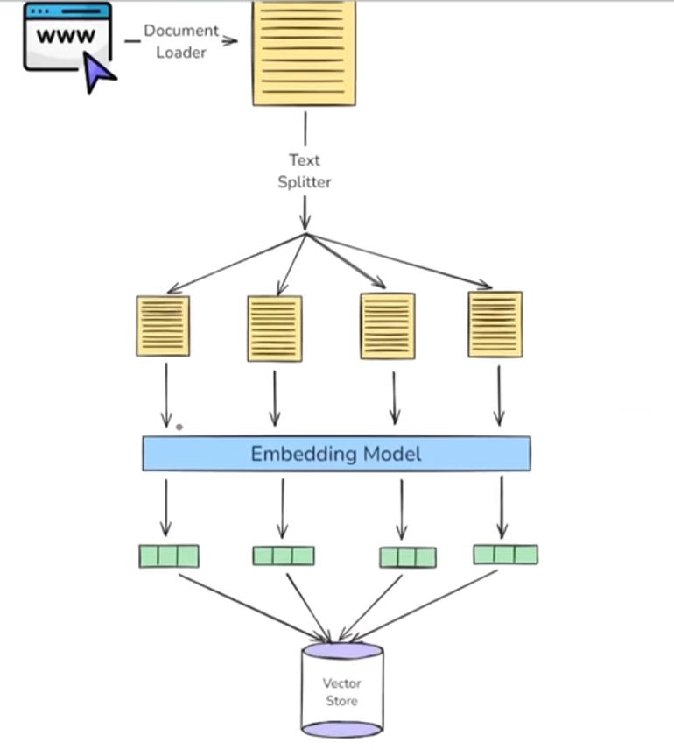

**Retrieval -** Retrieval is the real-time process of finding the most relevant pieces of information from a pre-built index (created during indexing) based on the user’s question.

It's like asking:

• From all the knowledge I have. which 3—5 chunks are most helpful to answer this query?"

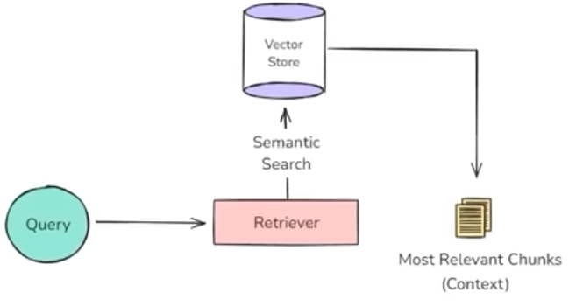

**Augmentation -** Augmentation refers to the step where the retrieved documents (chunks of

relevant context) are combined with the user’s query to form a new, enriched prompt for

the LLM.

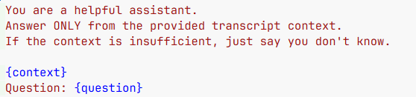

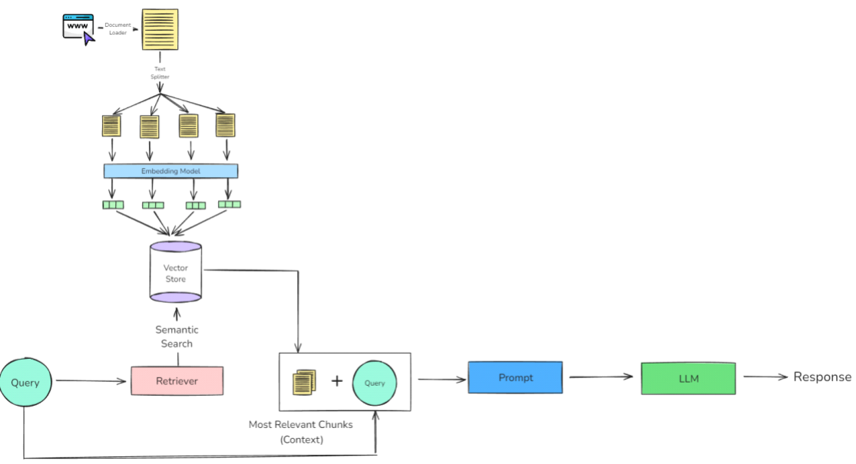

**Generation -** Generation is the final step where a LLM uses the user’s query and the retrieved & augmented context to generate a response.

**The final RAG Chain –**

retriever = vector_store.as_retriever(search_type="similarity", search_kwargs={"k": 4})

def format_docs(retrieved_docs):

    context_text = "\n\n".join(doc.page_content for doc in retrieved_docs)

    return context_text

prompt = PromptTemplate(

    template="""

        You are a helpful assistant.

        Answer ONLY from the provided transcript context.

        If the context is insufficient, just say you don't know.

        {context}

        Question: {question}

    """,

    input_variables = ['context', 'question']

)

client = ChatOpenAI(model="gpt-4o-mini", temperature=0.2)

parser = StrOutputParser()

parallel_chain = RunnableParallel({

    'context': retriever | RunnableLambda(format_docs),

    'question': RunnablePassthrough() })

main_chain = parallel_chain | prompt | client | parser

main_chain.invoke('Describe about the method of cheating for coding interviews.')

**Evaluation metrics** of RAG based systems –

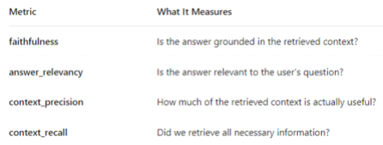

* **Tools:** A tool is just a Python function (or API) that is packaged in a way the LLM can understand and call when needed. They are also runnable (so, invoke etc. is available).

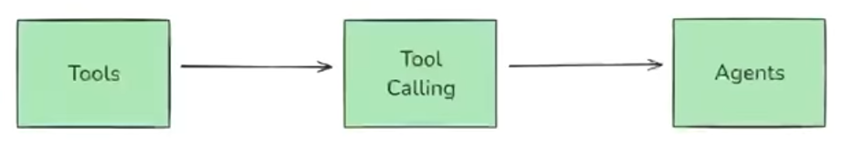

LLMs (like GPT) are great at: Reasoning (brain) & Language generation (mouth)

But they can't do things like:

Access live data (weather, news), Do reliable math, Call APIs,

Run code, Interact with a database

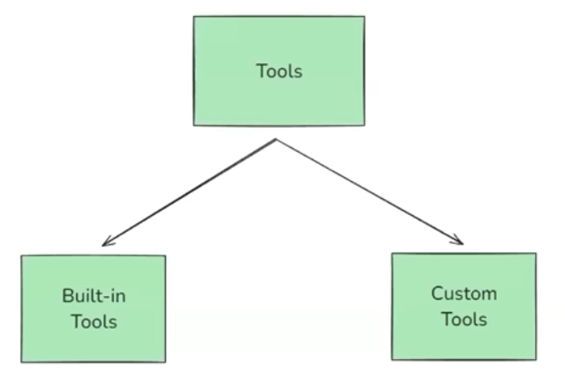

How Tools fits into the Agent ecosystem:

An AI agent is an LLM-powered system that can autonomously think, decide, and

take actions using external tools or APIs to achieve a goal.

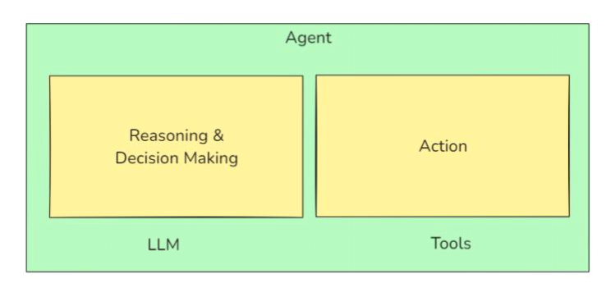

A ***built-in tool*** is a tool that LangChain already provides for you —it’s pre-built, production-

ready, and requires minimal or no setup. You don’t have to write the function logic yourself — you **just import and use it.**

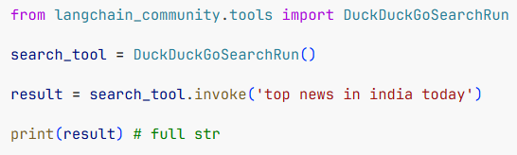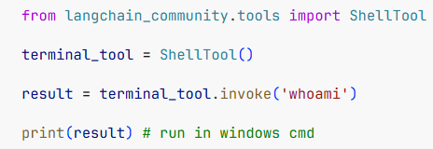

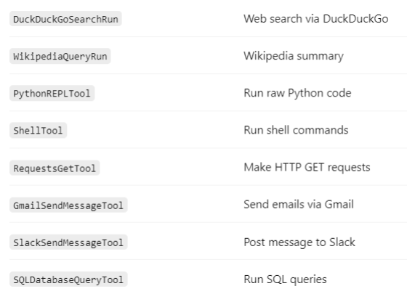

A ***custom tool*** is a tool that you define yourself. It’s basically a python function.

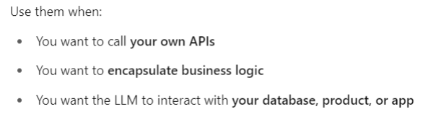

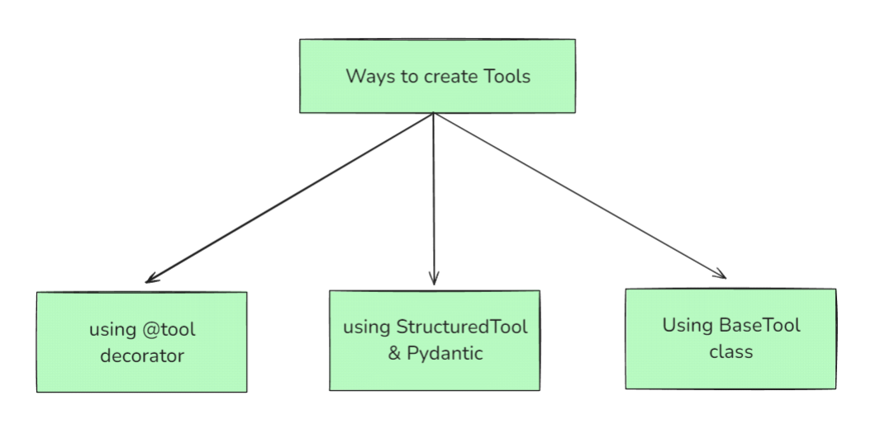

**BaseTool** is the abstract base class for all tools in LangChain. It defines the core structure and interface that any tool must follow, whether it's a simple one-liner or a fully customized function.

All other tool types like **@tool** decorator, StructuredTool are built on top of BaseTool.

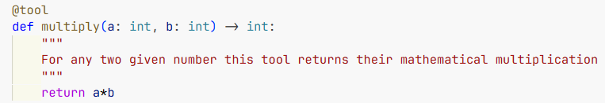

OR

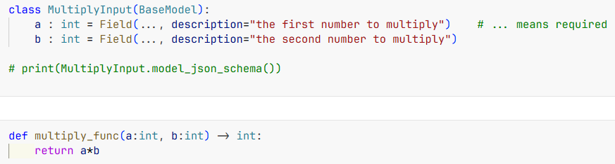

Then …

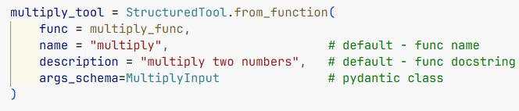

OR

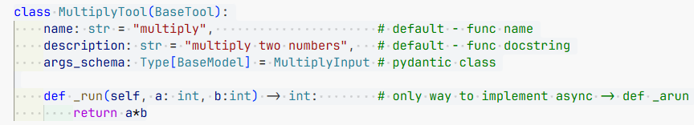

A **Structured Tool** in LangChain is a special type of tool where the input to the tool follows a structured schema, typically defined using a Pydantic model.

All tools have few common attributes, like-

tool.run( str or dict ) -> old version,

tool.invoke( ,, ) -> unified interface to run  
tool.name # 'multiply_tool'

tool.description # 'Multiplies two numbers'

tool.args_schema # <class '__main__.MultiplyInput'> (use .model_json_schema())

tool.schema() # JSON schema of input

tool.func # multiply_func

* **Toolkits:**

A toolkit is just a collection (bundle) of related tools that serve a common purpose —

packaged together for convenience and reusability. Ex -

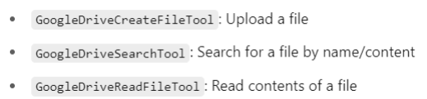

Custom Toolkit:

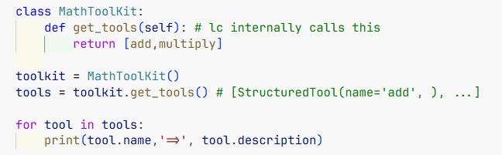

**Tool Execution/Use** –

query = “tell me the product of 11 with ten”

llm_with_tools = llm.bind_tools([multiply]) # RunnableBinding

result = llm_with_tools.invoke(query) # suggest tool_calls

tool_result = multiply.invoke(result.tool_calls[0])

llm_with_tools.invoke([hum(query),aim(result),tool_result])

**FYI – Runtime data injection –**

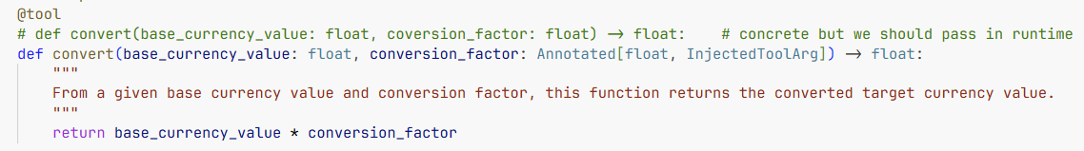

Then injecting the data later using



* **AI Agents:**

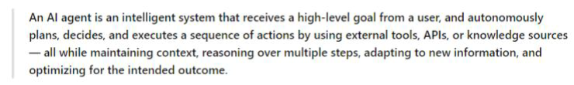

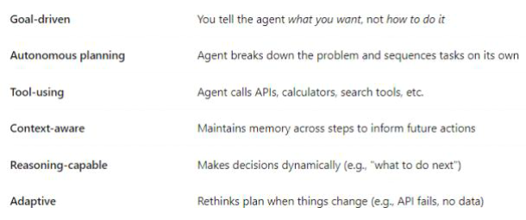

**ReAct –**

ReAct is a design pattern used in AI agents that stands for Reasoning + Acting. It allows a language model (LLM) to interleave internal reasoning (Thought) with external actions (like tool use) in a structured, multi-step process.

from langchain.agents import create_react_agent, AgentExecutor

from langchain import hub

prompt = hub.pull("hwchase17/react")  # pulls the standard ReAct agent prompt

search_tool = TavilySearch()

@tool

def get_weather_data(city: str) -> str: api_response_json

llm = ChatOpenAI()

agent = create_react_agent(

    llm=llm,

    tools=[search_tool, get_weather_data],

    prompt=prompt

)

agent_executor = AgentExecutor(

    agent=agent,

    tools=[search_tool, get_weather_data],

    verbose=True

)

response = agent_executor.invoke({"input": "…”})

response['output']

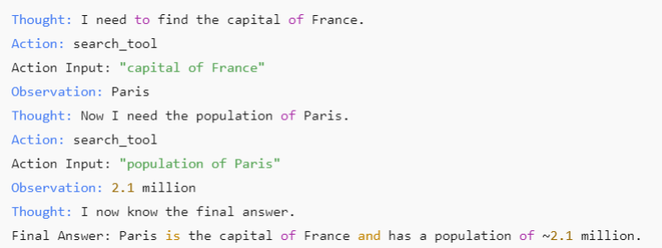

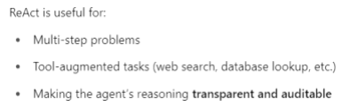

**Agent & Agent Executor**:

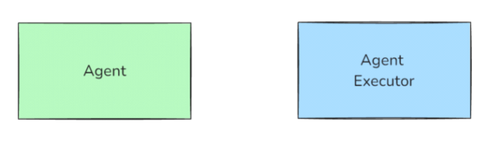

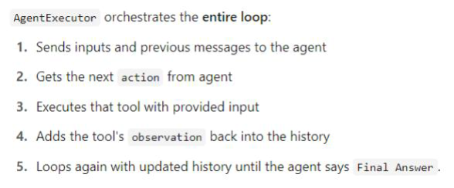

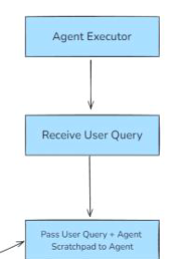**Flow-chart:**

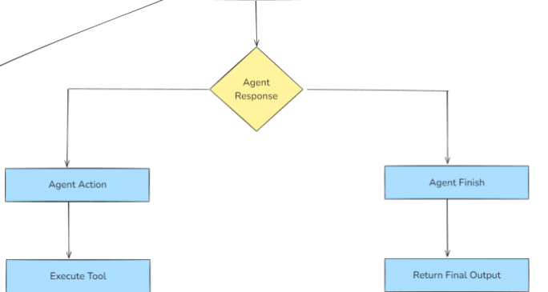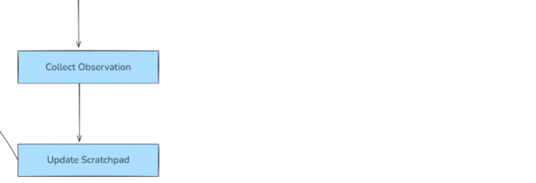

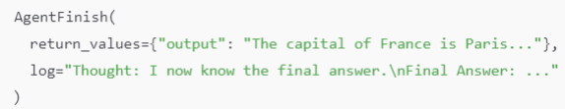

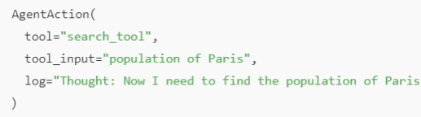

**Example of flow-**

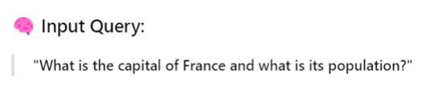

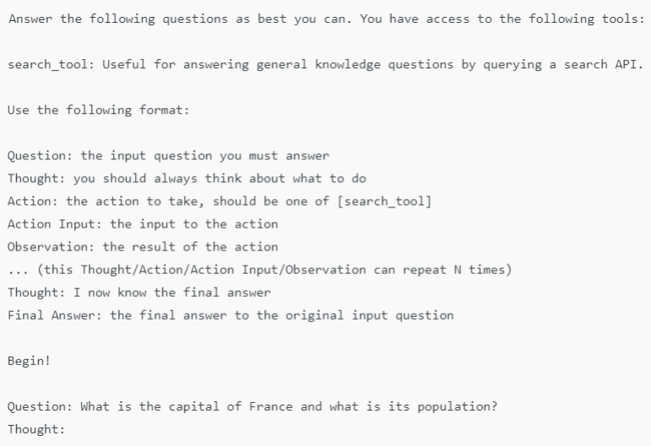

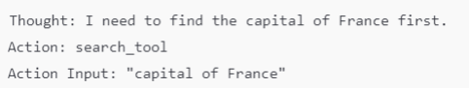

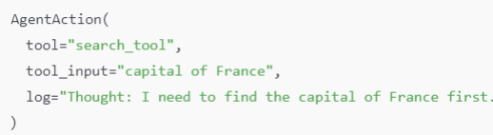



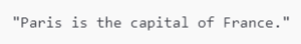

Agent scratchpad (history) now looks like -

